**Report**

**Section B**

I’ve implemented Early Stopping Using Validation Set. Since the dataset was too large only 8K Training and 2K Validation Samples are Used. The Training is set for a maximum of 100 epochs.

Activation Function Testing:

Sigmoid: Accuracy: 0.1135

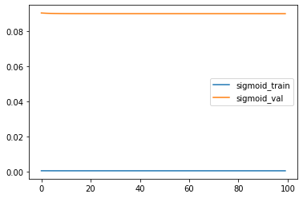

Relu: Accuracy: 0.9163

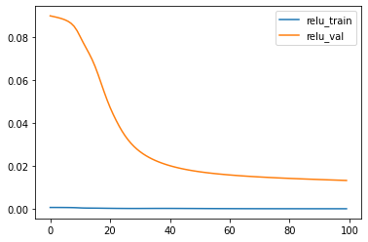

Tanh: Accuracy: 0.9193

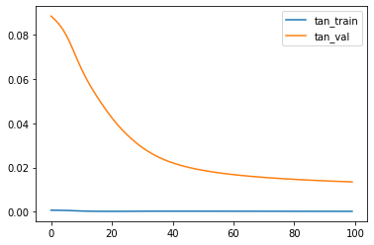

Leaky Relu: Accuracy: 0.9138

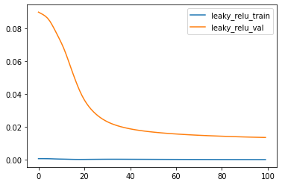

Linear: Accuracy: 0.9056

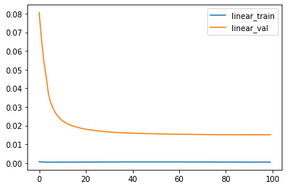

Hence the Best Activation Function is – Tanh

However, Tanh, relu and leaky relu all 3 are fairly close.

Suprisingly Sigmoid performs very poorly which might be because of the poor suitability of sigmoid for this task as compared to other activation functions.

Weight Initialization Testing:

To Compare different Initializations, I only run the model for 20 epochs to see signs of convergence and see which initialization works better

Normal Init: Accuracy: 0.6699

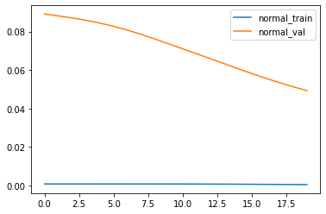

Random Init: 0.1135

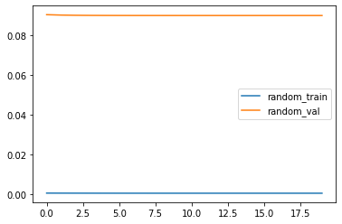

Zeroes: Accuracy: 0.1135

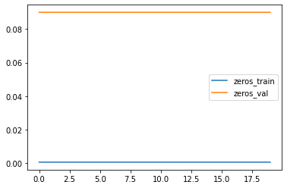

Zeroes Initialization and random initialization work poorly. For the first one as the model updates are similar and it fails to learn more features. For the second one randomness can be unfavourable and hence it can and cannot work depending on the case.

**Section C**

1. For Sigmoid:

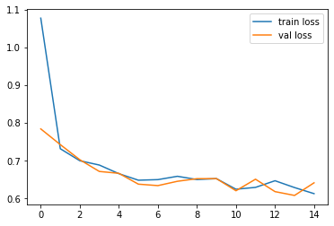

For RELU:

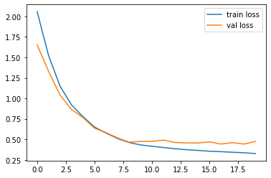

For Tanh:

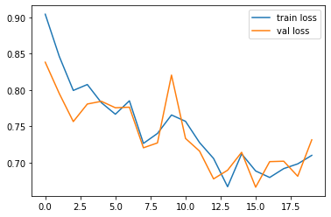

For Linear:

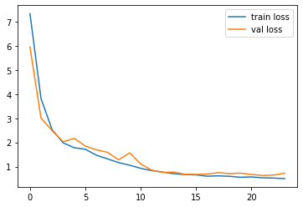

|  |  |
| --- | --- |
| Activation Function | Accuracy |
| Sigmoid | 0.742 |
| Relu | 0.852 |
| Tanh | 0.7083 |
| Linear | 0.7959 |

Hence Relu has the best accuracy and has a smooth loss curve indicating it’s the best choice. The main reason Relu performs so well is that it doesn’t activate all neurons at the same time and hence it selects some neurons to activate making the other neurons compensate and learn.

1. Learning Rate: 0.1

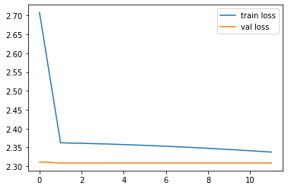

Learning Rate: 0.01

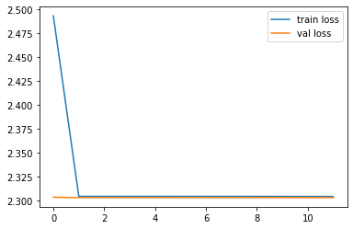

Learning Rate: 0.001



|  |  |
| --- | --- |
| Learning Rate | Accuracy |
| 0.1 | 0.1 |
| 0.01 | 0.1 |
| 0.001 | 0.8512 |

Hence 0.001 is the best learning rate. The other learning rates fail to converge. Their graphs also have sharp turns. This implies that these learning rates are too high we might take too large of a step and cross the minima

1. (64,64) Neurons

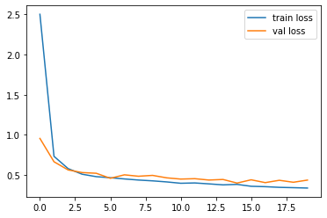

(128, 64) Neurons

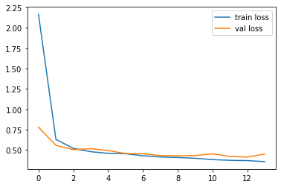

(128, 128) Neurons

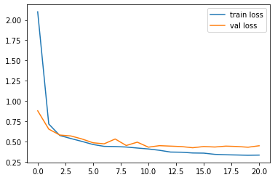

(128, 32) Neurons

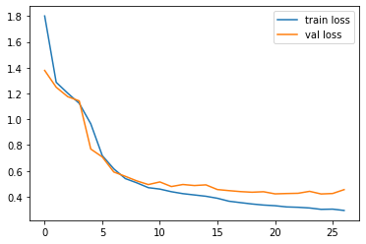

(64,32) Neurons

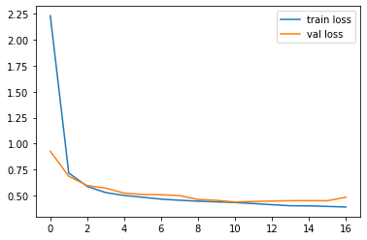

|  |  |
| --- | --- |
| Hidden Layer Sizes | Accuracies |
| (64,64) | 0.8603 |
| (128,64) | 0.8405 |
| (128,128) | 0.85 |
| (128,32) | 0.8533 |
| (64,32) | 0.8336 |

As we can see by the accuracies the hidden dimensions (128,32) works best

1. After Performing Grid Search the Best Model is –

'activation': 'relu',

'batch_size': 32,

'early_stopping': True,

'hidden_layer_sizes': (128, 64),

'learning_rate_init': 0.0001,

'random_state': 1,

'solver': 'adam',

'validation_fraction': 0.15

It gives the accuracy 0.8751 which is better than all values seen before. This is also expected as these values performed well independently and together, they perform even better.

The adam solver is often used in DL Architectures and hence due to it’s complex nature it might be performing well.